Get the data from the room and put it in the form:

Edit the ngOnInit() in the RoomEditComponent class

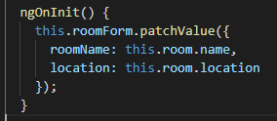

The result: roomName and location are being populated

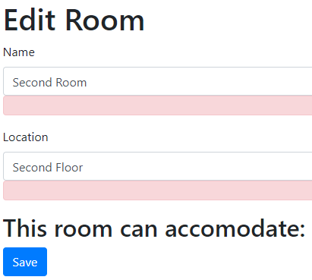

Now fix the onSubmit() method or onSubmission() method

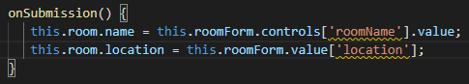

Test it! Editing the room name and location

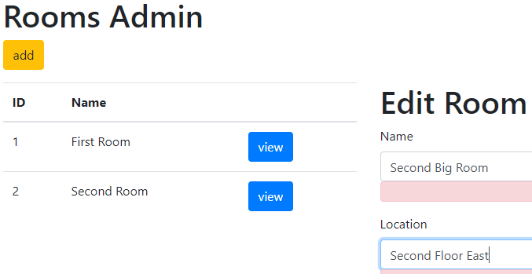

Click on Save

